

**Bellhouse Landfill Site – Update**

**Disposal Operations**

The site continues to operate two disposal areas to accommodate the different types of vehicles using the site. Small “bin wagon” type vehicles are being tipped on an area of Cell 8-9 on top of the site. This area requires filling to level to allow it to then be capped, with capping works to follow once the area is to level.

The second tipping area is in the new cell, Cell 11b, this area is the main disposal point for all other wastes and vehicles. Waste is being placed in a regimented and specified sequence as it is placed against the existing waste in Cell 11a. Cell 11a suffered a slip in July which has since been remediated and placement of waste in Cell 11b is being carried out in a way which provided a buttress to further support Cell 11a. The site continues to accept waste from Essex County Council which is comprised of residual waste in black bin bags, plus bulky wastes. The site also accepts a range of other non-hazardous wastes from a wide range of local waste management companies.

The site has planning permission to accept waste until December 2026, but the Essex waste disposal contract, for use of the site, will come to an end in March 2025. From April 2025 the site will continue to operate and to accept third party non-hazardous commercial waste until December 2026. After this time the remaining capping and restoration works will be completed to restore the site. The site will then enter into aftercare, during which time no wastes are accepted but the site will continue to be actively managed by Enovert to ensure permit compliance and management of leachate and landfill gas.

In July this year a new section of concrete haul road was installed on the top of the site to allow for winter access for restoration soils, the road will also eventually be used to access the top of cell 11a-c as the waste increases in height in those areas.

**Landfill Gas & Generations**

During September, 14 of 23 new gas extraction wells have been installed across Cells 10, 11 and future capping areas, in order to extend the gas capture network as infilling moves forward around the site. These wells are connected to a series of gas engines which use the gas as a fuel to generate renewable energy, this electricity is then exported into the local electrical distribution network. The site is currently, in September 2024, generating c.3MW which is less than normal whilst one of the engines is undergoing routine maintenance. During the maintenance period, the sites flare is used to manage any gas that would otherwise be used for generation.

Drilling rig on-site during September 24 installing new gas wells

**Engineering**

The basal engineering of 11b was completed during the summer ahead of waste being disposed in that cell. Cell 11c, the final cell, is scheduled to be engineered before the end of 2024, providing weather permits its construction. Additionally, within the next 3-4 weeks engineered clay liner is due to be placed on the upper sidewall of Cell 11b as the waste in that cell increases in height.

A significant area of permanent capping, the engineering system placed over the waste on completion, that in conjunction with the basal and sidewall lining systems provides complete containment of the waste, has been installed so far this summer. Approximately 30,000 square metres of permanent capping has been installed, which means capping is tight behind the area of fill, as is good practice. Weather permitting, further capping will be completed during September / October. As a good practice measure, a further 12,000 square metres of temporary plastic capping will also be installed to aid collection of landfill gas until the permanent cap can be installed.

Left - temporary plastic cap+ gas Cell 9-10 western flank. Right – permanent capping being installed

**Leachate Treatment**

The on-site treatment plant is currently treating 14 cubic metres of leachate each day, the site also continues to tanker leachate, liquid collected from within the waste, off site to permitted treatment facilities. Plans are being considered to increase the treatment capacity of the on-site treatment plant, for treatment of the sites own leachate only. These plans are part of the assessment of the impact of climate change which has generally seen longer period of wetter weather in the UK.

**Restoration**

Following installation of the engineered cap, restoration soils are being placed, these are placed to a minimum 1.3m depth over the top of the site to allow for cultivation with grass and thicker in areas of tree planting to prevent damage to the capping system. Restoration at the site is progressive with areas completed when available instead of waiting to commence these works at the end of waste disposal operations. Once restoration is completed and the final infrastructure installed to manage gas and leachate, the aftercare period can then commence in that part of the site. During this aftercare period, public access will be provided via a network of paths around the site and linking into adjacent former Essex County Council landfill site and the wider footpath network.

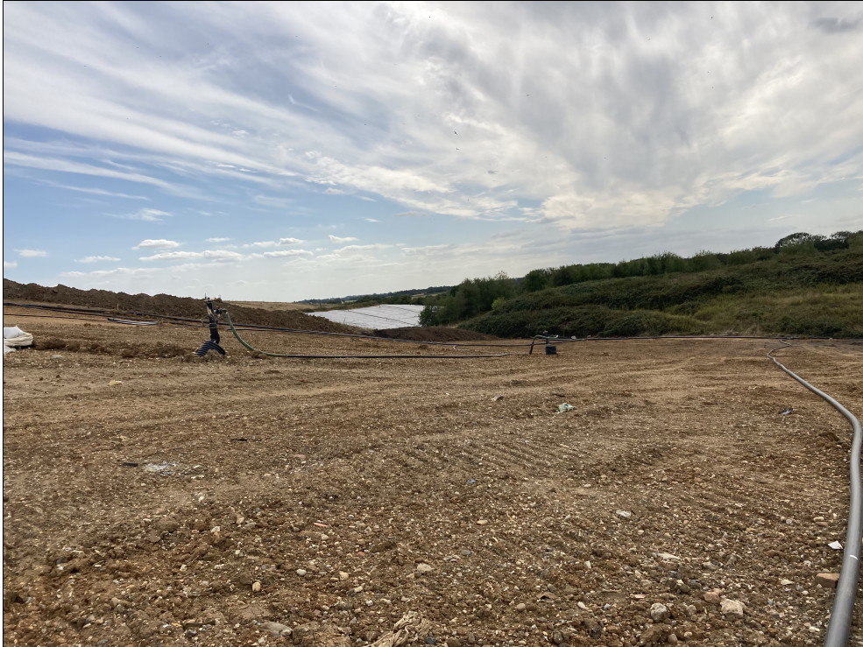

Restoration soils applied (foreground) and area of permanent capping (background)